**Computer networks laboratory week 6**

**Name: Pranav R. Hegde SRN: PES1UG19CS343 Section: F1**

**Topology 1**

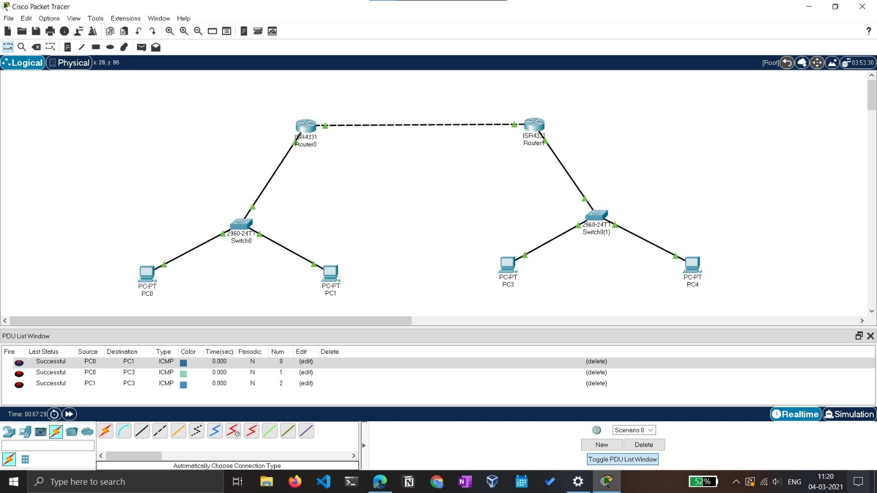

* Construct a basic topology with two subnetworks joined together by two routers and switches. Configure them with their suitable IP’s and gateways.
* Ping the last PC through first PC passing through both the routers and switches.

The topology:

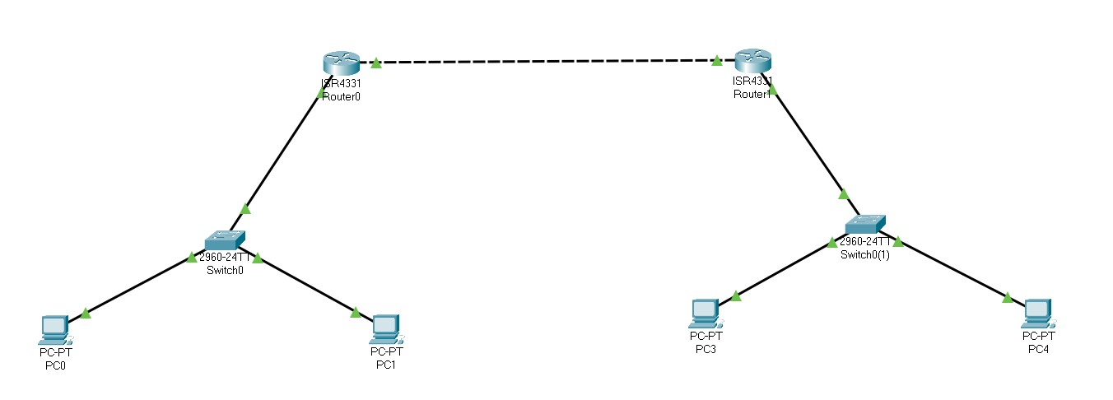

Ping results:

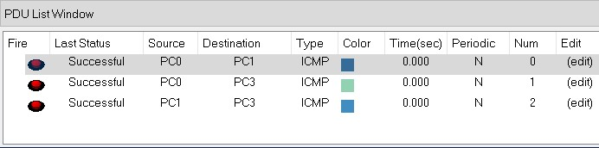

**Topology 2**

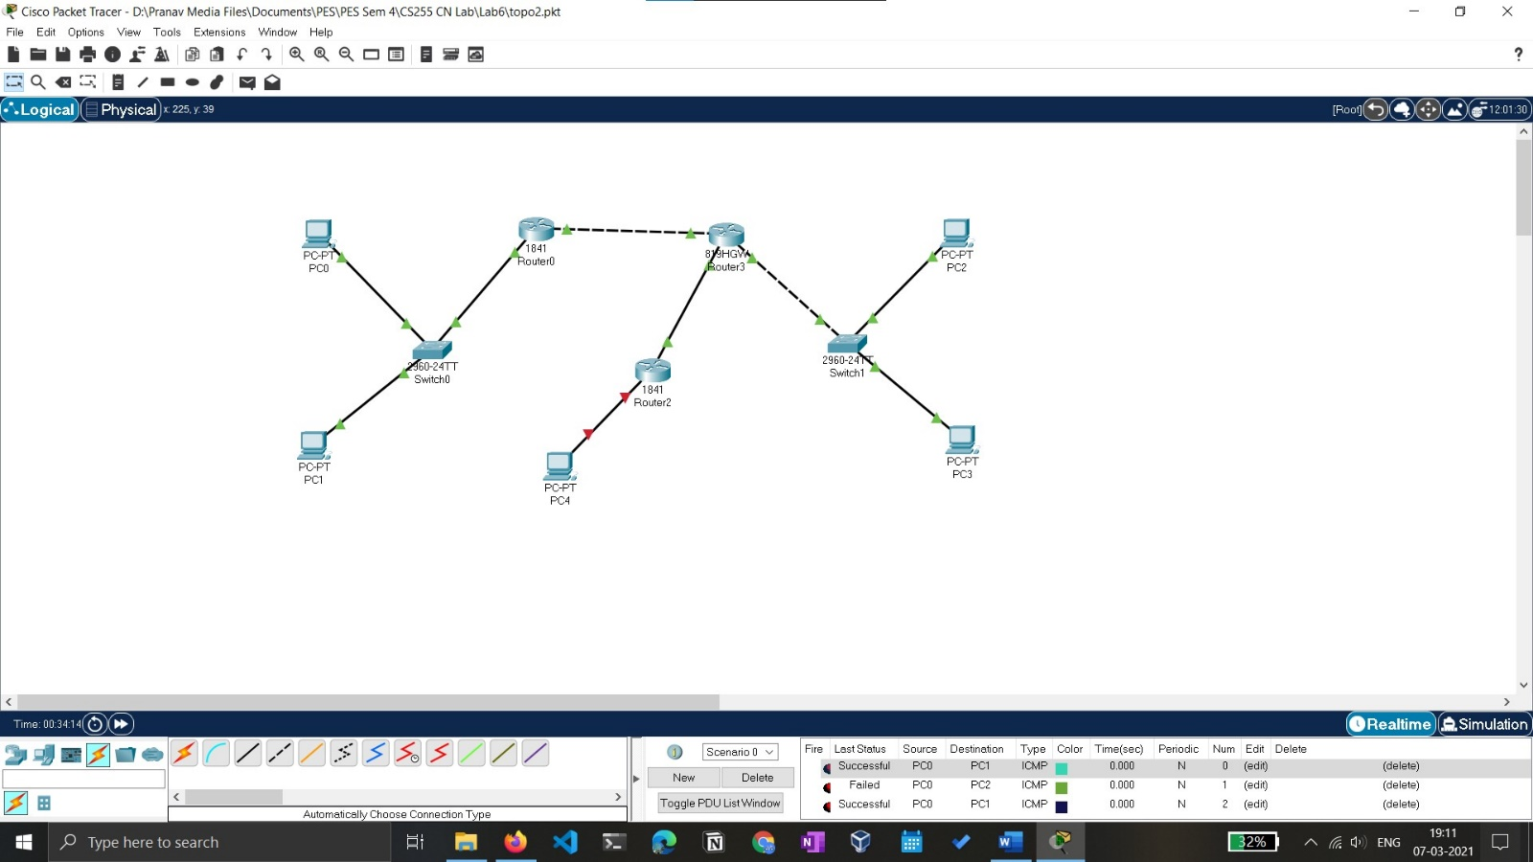

* Construct a basic topology with three subnetworks joined together by three routers and switches. Configure them with their suitable IP’s and gateways.
* Ping the last PC through first PC passing through both the routers and switches.

The topology:

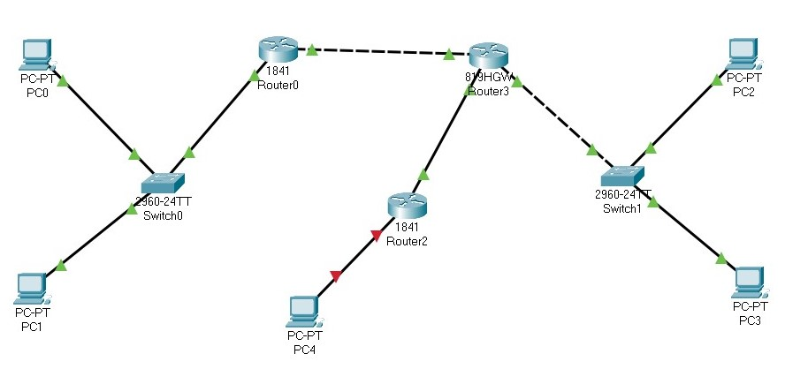

Ping results:

